Floral variations of wild Yunnan camellia at Mt. Zixi, Chuxiong City, Yunnan Province, China
Toshiaki Shiuchi*, Tadashi Kanemoto¹, Zhonglang Wang², Jingxiu Li²
¹Botanic Gardens of Toyama, 42 Kamikutsuwada, Fuchu-machi, Toyama 939-2713,Japan
²Kunming Institute of Botany, Chinese Academy of Sciences, Kunming, Yunnan, 650204, China

ABSTRACT Floral variations of wild Yunnan camellia were found in Mt. Zixi, Chuxiong City of Yunnan Province, China. The floral characteristics and pollen stainability were investigated comparing with the typical wild population at Mt. Heiniu. The population of Mt. Zixi showed rich flower color and much bigger in the size of flower diameter and the number of petals than Mt. Heiniu population. Pollen stainability of Mt. Zixi population was more than 74.8% of the mean, and significant difference was indicated in each population. It seems that the cross plants between horticultural cultivars planted in the temple and the wild camellias have escaped to the wild. Thus, it was suggested that the flower diversity of the wild camellias in Mt. Zixi were strongly influenced by those camellias planted in temples.
KEY WORDS Yunnan camellia, floral variation, horticultural cultivar, hybridization, Mt. Zixi,

Camellia reticulata Lindl. is widely distributed from the northwest part of Yunnan Province, through southern part of Sichuan Province, to western Guizhou Province in China, which were native to the evergreen broadleaved forest altitude from 1500m to 2800m (Min 1997). Yunnan camellia is commonly referred including Camellia reticulata native to field and horticultural cultivars. Yunnan camellia cultivars have mostly been selected from wild Camellia reticulata originally but the creation of new cultivars has been performed through selection by breeding the related species or bud mutations/sports recently(Feng et al. 1986). There is a large Yunnan camellia forest in Yunhua of Tengchoung in Yunnan province, which is from single to double petals in the wild (Feng et al. 1986). In addition, it has also been reported for a group of semi-double flower with beautiful flowers in Baotaishan Mountain at Yongping Dali Prefecture, Yunnan Province in the field (Shiuchi et al 2011). Thus, it is likely to be found of valuable Yunnan camellia cultivars from the fields of Yunnan Province which has high-quality resources in the future.
In Mt. Zixi, thousands of Yunnan camellias are distributed in wild and are preserved a lot of precious cultivars such as ‘Xiangguo Cha’ and ‘Donglin’, Zixishan Mountain, which many temples have been constructed from the ancient, was also a land villa within the territory of Dali Kingdom and had been planted with various flowers and trees (Chuxiong City Construction Bureau 2000).
During the survey in Mt. Zixi early spring of 2009, Yunnan camellias with the various flower in wild were confirmed. Some of these plants were also included valuable to horticulture. Shiuchi et al. (2012) has already reported the morphological variations of wild Yunnan camellia at Mt. Zixi in Japanese. The status of the characteristics of flowers and flower colors in the wild Yunnan camellia at Mt. Zixi were briefly reported in this paper.

MATERIALS AND METHODS
The Yunnan camellias of various flower types from single flower to semi-double flower, as well as rich flower colors occurred near the Nianfotang at Mt. Zixi, Chuxiong City of Yunnan Province, China. For examination of floral differentiation, the materials used for this study were randomly collected in the wild Yunnan camellia at Mt. Zixi and typical wild Yunnan camellia at Mt. Heiniu (Table 1). One flower per plant was sampled and the stamen was fixed with 70% alcohol solution. The flower colors were measured by the device of Color Reader CR-11 (Konica Minolta Sensing, Co., Japan). The device indicates values by the Munsell color system. The method of measurement is according to Nakata et al (2008). The following characters were measured: flower diameter, flower height, pistil length, stamen length, stamen width, ovary length, ovary width, and the mean length and width of largest three petals, and the number of stigma and petals were counted.
Table 1 Table 1. Locations and the number of plants of Yunnan camellias examined. (Shiuchi et al. 2012)
Code | Locations | No. of plants examined | Altitude (m)
ZXW | Wild yunnan camellia at Mt. Zixi, Chuxiong City, Yunnan Province, China | 21 | 2280～2340
HNW | Wild yunnnan camellia at Mt. Heiniu, Chuxiong City, Yunnan Province, China | 25 | 2279～2425

Pollen with three anthers from each flower were gently squashed on a glass slide in a drop of idodine-potassium iodide staining solution and the pollen stainability was observed under a microscope.

RESULTS AND DISCUSSIONS

Flower colors and morphological variations
As a result of the measurement, nine types of flower colors were confirmed in the wild population of Mt. Zixi and seven types of colors were in Mt. Heiniu (Fig. 1, Table 2). The variety of flower colors showed rich flower colors in Mt. Zixi population than those of Mt. Heiniu.
Table 2 Flower colors of Yunnan camellias examined. (Shiuchi et al. 2012)
ZXW population | Flower colors | HNW population
ZXW-3, 20 | 2.5R4/12 | HNW-1, 2, 7, 21, 23, 24, 25
 | 2.5R5/12 | HNW-4, 9, 12*, 13, 17
 | 5R4/12 | HNW-5, 11
ZXW-13 | 7.5RP5/12
 | 7.5RP6/10 | HNW-16
ZXW-8 | 7.5RP6/8
ZXW-6, 9, 11, 15 | 7.5RP6/10
ZXW-18 | 7.5RP6/12
ZXW-1 | 10RP4/10
ZXW-2, 7, 10 | 10RP5/10
ZXW-4, 12, 14, 16, 17, 19, 21 | 10RP5/12 | HNW-6, 8, 10, 14, 15, 18*, 19, 20, 22
 | 10RP6/10 | HNW-3, 12*
 | 10RP6/12 | HNW-18*
ZXW-5 | 10RP7/6
*Two types of flower colors were confirmed in HNW-12, 18.
It is known that the horticultural cultivar of 'Tongzimian'(baby face) with the whitish flowers color originated from Mt. Zixi (Chuxiong City Construction Bureau 2000). A similar flower color were seen the number of ZXW-5 as a whitish flower color. It is considered that a gene remain to make a flower color white in the Mt. Zixi population.
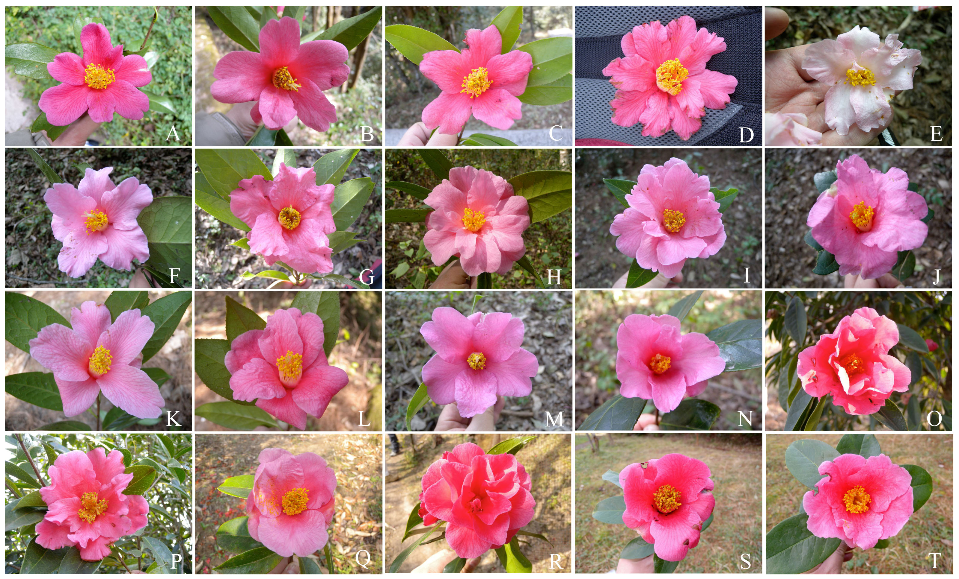
Fig. 1 Flowers of wild Yunnan camellia at Mt. Zix population.
A ZXW-1. B ZXW-2. C ZXW-3. D ZXW-4. E ZXW-5. F ZXW-6. G ZXW-7. H ZXW-8. I ZXW-9. J ZXW-10.
K ZXW-11. L ZXW-12. M ZXW-13. N ZXW-15. O ZXW-16. P ZXW-17. Q ZXW-18. R ZXW-19. S ZXW-20.
T ZXW-21. No photo of ZXW-14. (Shiuchi et al. 2012)
Regarding the floral characteristics, the significant difference was observed in flower diameter and petal width (ANOVA, p<0.05) and the number of petals (Mann-Whitney's U-test, p<0.01) (Table 3). It was found that the flowers of Mt. Zixi have greater in the size and large number of petals with a diverse flower colors compared to the Mt. Heiniu.
Table 3 Morphological variations of floral charactaristics and the numbers of stigma and petals per flower in Yunnan (Shiuchi et al. 2012)
Character | ZXW population (mean±s.d.) | HNW population (mean±s.d.)
Flower diameter (cm) | 8.2±1.5 | 7.2±1.3*
Flower height (cm) | 5.8±0.9 | 5.9±0.7
Pistil length (mm) | 36.2±5.0 | 35.4±4.4
Stamen length (mm) | 33.1±4.0 | 34.5±6.1
Stamen width (mm) | 13.8±2.3 | 14.8±1.8
Ovary length (mm) | 4.1±1.0 | 4.4±0.9
Ovary width (mm) | 4.9±0.8 | 4.9±0.8
Petal length (mm) | 54.3±6.0 | 53.3±7.6
Petal width (mm) | 32.8±6.8 | 37.7±6.7*
Number of stigma | 3.9±0.8 | 3.8±1.0
*Significant difference between ZXW and HNW were found by ANOVA (p＜0.05)
**Significant difference between ZXW and HNW were found by Mann-Whitney's U-test (p＜0.01)

Pollen stainability
As for observation of pollen stainability, significant difference was found in the rates of normal and abnormal pollen between each population (ANOVA, p<0.05) (Table 4). There was no significant difference in the rates of Pseudopollen in each population. The rates of normal pollen grain 74.8% in Mt. Zixi were less than 87.4% in Mt. Heiniu but the abnormal pollen grain was greater in Mt. Zixi. The low staining of normal pollen grain in the population were thought to be caused by only some plants, e.g., ZXW-7 (38.9％), ZXW-20 (47.9％), ZXW-21 (12.7％). Owing to high rates of pollen staining, the flowers of Mt. Zixi were likely to pollinate with another plants, such as Yunnan camellia cultivars and another species of Camellia growing in Mt. Zixi.
Table 4 Comparisons of pollen stainability. (Shiuchi et al. 2012)
Collection sites | Normal pollen*  mean±s.d. | Abnormal pollen*  mean±s.d. | Pseudopollen  mean±s.d.
ZXW (n=21) | 74.8±22.2 | 12.3±16.0 | 12.9±8.4
HNW (n=24**) | 87.4±8.5 | 3.4±4.2 | 9.2±5.7
* Significant difference between ZXW and HNW were found by ANOVA (p＜0.05)
It is noteworthy that degenerated small stamens (anthers) did not produce pollen grain on HNW-17 in the typical wild population at Mt. Heiniu. It is believed that this plant is female caused male sterility.

Origins of the flower variations in the wild Yunnan camellias at Mt. Zixi
According to the observations of pollen stainability, it is possible to crossing to other Yunnan camellias. Shiuchi et al. (2012) have reported that eight of horticultural cultivars planted in Mt. Zixi which were pollen stainability of the mean 82.8%. It could be hybridized between their horticultural cultivars and wild Yunnan camellia in Mt. Zixi in addition to not only between wild Yunnan camellias but also themselves.On the other hand, the flower variations might be produced by the natural hybrid between wild Yunnan camellias and another Camellia species, C. saluenensis Stapf ex Bean and C. pitardii Cohen-Staut var. yunnanica Sealy occurred nearby the study area. However, it may be suspected that the flower variations in Mt. Zixi population was produced by breeding with the cultivars planted in the mountains involves for the following reasons.
Yunnan camellia cultivars have been planted in temple as a sacred tree at northwest of Yunnan Province (Yamashita et al. 2009, Shiuchi et al. 2010a, 2010b). The rebuilding of many temples had been repeated in Mt. Zixi after the destruction by earthquake and fire (Chuxiong City Construction Bureau 2000). It is likely to escape the seedlings of introgressive hybridization between horticultural cultivars and wild Yunnan camellias because some horticultural cultivars in Mt. Zixi have been planted on the field. In fact, the population of Mt. Zixi was collected near Buddhist Temple in the young secondary forest which is estimated to be harvested many decades. The origins of the diverse population should clarify by using for molecular markers specific to Yunnan camellia cultivars.

ACKNOWLEDGEMENTS
The authors would like to thank the People’s Government of Chuxiong City, the Forestry Bureau of Chuxiong City as well as Chuxiong Camellia Society for their helpful support in the field survey. This study was partly supported by the Commemorative Foundation for the International Garden and Greenery Exposition, Japan.

REFERENCES
Chuxiong City Construction Bureau. 2000. Records of Zixishan Mountain. 301pp. The Nationalities Publishing House of Yunnan. Kunming, China. (in Chinese)
Feng Guomei, Xia Lifang and Zhu Xianghong, 1986. Yunnan Camellias of China. 169pp. Sciences Press, Beijing, China.
Nakata, Masashi., Wang, Zhonglang., Lu, Yuanxue., Feng, Baojun., Wang, Shuang., Guan, Kaiyun. and Godo, Toshinari. 2008. Outdoor measurement of flower colors of Camellia reticulata (Theaceae) using a portable device that indicates values by the Munsell color system. Hort. Res. (Japan) 7(1): 139－143. (in Japanese)
Min, Tianlu. 1997. Theaceae. Institute Botanicum kunmingense academiae sinica edita. Flora Yunnanica. Tomus 8. Pp. 263-308.Science Press, Beijing. (in Chinese)
Shiuchi, Toshiaki., Kanemoto, Tadashi., Li, Jingxiu., Wang, Zhonglang., Wang, Shuang., Feng, Baojun. and Guan, Kaiyun. 2010a. Registration of old camellia trees in Yunnan Province, China. Bull. Bot. Gard. Toyama 15: 45－61. (in Japanese)
Shiuchi, Toshiaki., Kanemoto, Tadashi., Yamashita, Toshiyuki., Godo, Toshinari., Nakata, Masashi., Uchimura, Etsuzou., Wang, Zhonglang., Lu, Yuanxue., Feng, Baojun., Li, Jingxiu., Wang, Shuang., and Guan, Kaiyun. 2010b. Cooperative studies on conservation of Camellia reticulata in Yunnan Province, China. Bulletin of Japan association of botanical gardens 44: 189－196. (in Japanese)
Shiuchi, Toshiaki., Yamashita, Toshiyuki., Wang, Zhonglang. and Guan, Kaiyun. 2011. Flower diversity of wild Camellia reticulata at Baotaishan in Yongping County of Yunnan Province, China. Bull. Bot. Gard. Toyama 16: 1－8. (in Japanese)
Shiuchi, Toshiaki., Kanemoto, Tadashi., Li, Jingxiu., Wang, Zhonglang., Feng, Baojun. and Guan, Kaiyun. 2012. Morphological variations of wild Yunnan camellia at Mt. Zixi, Chuxiong City, Yunnan Province, China. Bull. Bot. Gard. Toyama 17 (in Japanese) (in press).
Yamashita, Toshiyuki., Shiuchi, Toshiak.i, Wang, Zhonglang., Shuang, Wang., Lu, Yuanxue. and Guan, Kaiyun. 2009b. Registration of old, large and wild trees of Camellia reticulata in Yunnan Province, China; records of 2008 field survey. Bull. Bot. Gard. Toyama 14: 47－56. (in Japanese)

* Author for corresponding: t-shiuchi@bgtym.org

